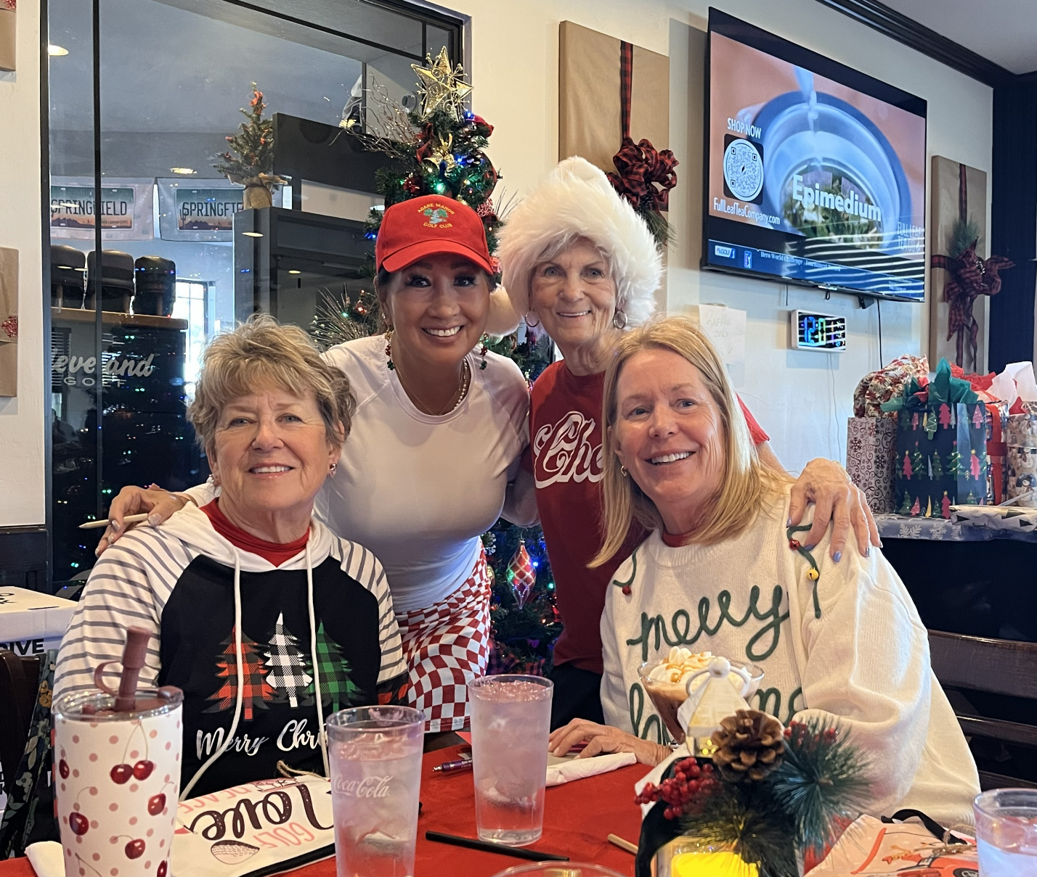
Bonnie McFarlane
Hyn Ju Crahan
Candy Jones
Lisa O’Brien

